WARLEY MEDICAL CENTRE

PATIENT PARTICIPATION GROUP

Minutes of Patient Participation Group held on Monday 8th January 2024 at Warley Medical Centre.

Present: Vic Silvester (Chair)
Vicky Clayton (Practice Manager)
Janet Walters (Medicines Manager/PPG Lead)
38 People as per the signing in sheet

Apologies: A number of apologies had been received, sickness etc.

Minutes of the Last Meeting: Minutes of the last meeting had been circulated to members by email.

Chair Remarks:
The meeting held in October had been a very successful meeting and the presentation by Emma Hall (Sandwell Hospital} on Prostrate Cancer was well received by members present. Copies of the presentation are available.

The PPG requires a Secretary to help with the administration of the PPG and also to take notes of the meeting - further information can be provided by the Chair on 07790 800 463.

The Chair then asked for persons to volunteer to form a Committee to help with the organisation and running of the PPG. If you are interested is being on the PPG Committee please let the Chair know by email: vic.silvester@btinternet.com.

Surgery Matters:
A small number of complaints had been received regarding appointments with doctors and the nurses. It was explained that owing to sickness of doctors and nurses some appointments were not available. The Practice Manager informed the meeting that appointments could be made for three weeks ahead for the next two months. This would then go back to 2 weeks in advance from March. Once the pre-bookable appointments have been taken the rest are then released on the day.

Flu vaccines are still available at the surgery for eligible patients until 31st March 2024. Contact the surgery to book an appointment with the nurse.

Recent Friends and Family responses were positive.
154 surveys returned out of 200
127 positive
11 neither good nor bad
15 negative
1 unsure

The negative feedback was mainly regarding patients who were kept waiting for their appointments with the doctor.

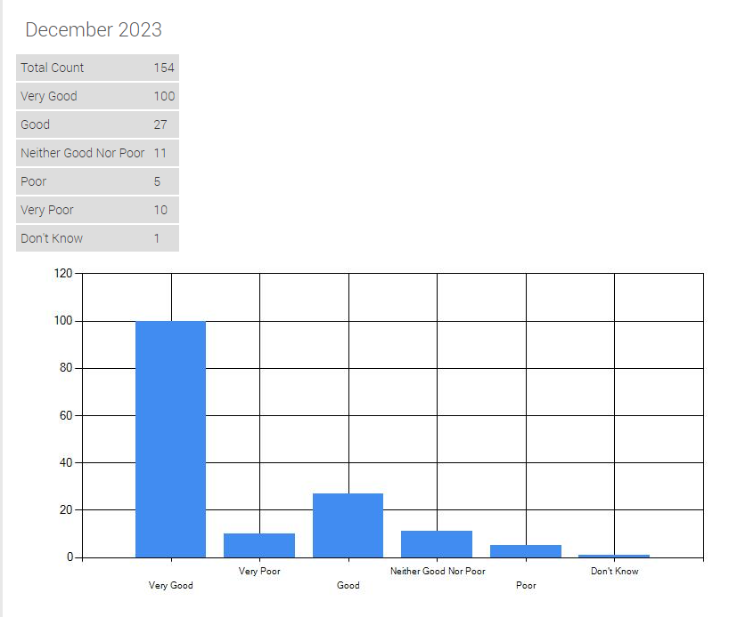

Dementia:
Claire Mahmood From BUDS - Better Understanding of Dementia for Sandwell made a presentation on dementia as follows: “Dementia is currently the leading cause of death in the UK. It is a disease of the brain that affects how the brain functions. It is a progressive disease, how quickly it progresses varies depending on the individuals physical health, the type of dementia and their age, Dementia is diagnosed in various ways, the GP can sometimes diagnose, or they may refer you to the Memory Assessment Service. Dementia generally affects the person in the following ways, short term memory loss, becoming repetitive in their behaviour and what they are saying, lack of judgement of distances, surfaces etc. Many people with dementia lose the ability to tell the time or understand the concept of time, for example 5 minutes can feel like an hour.

A person’s emotions can become erratic, depression and anxiety are common in people with dementia. Many lose their sense of self esteem, they can feel like they doubt having a ‘role’ anymore. It is important that people with dementia retain their self-worth and are encouraged to remain an active member of their family and their communities. Becoming socially isolated can impact negatively on a person’s dementia, the longer they can stay physically and socially active the better.

There is a range of support available in Sandwell, the Sandwell Community Dementia Service supports people living with dementia and their families from diagnosis to end of life.”
Information on dementia can be obtained from:
www. buds.co.uk 0121 565 3721 https.//www.murryhall.co.uk/svds

Claire Mahmood works for BUDS which is based at Barlow Community Hall, Pound Road, Oldbury and it offers advice to families who have a family member with dementia. BUDS hold daily sessions for people with dementia in that transport is laid on, activities are arranged during the sessions and a hot meal is provided.

The Chair thanked Claire for the excellent presentation.

Health Watch Sandwell:
Melissa Elders made a short presentation on what Health Watch Sandwell do; “Healthwatch Sandwell is an organisation that has been set up to enable the view and experiences of people who use services to influence and improve the way the health and social care services are provided and run.
We can also signpost people:
      - to make formal complaint and can link them with advocacy services
      - to local services, i.e. someone might need carers support- Carers Assistance Line (CAL)
Guided by You follow up events have started -You Shared, We Heard.”

The Chair thanked Melissa for her presentation.

Any Other Business:
The Chair asked members present for ideas of what subject they wish to have raised at future meeting. It was suggested that we get a speaker on the Menopause for the next meeting.

Meeting closed at 6.25pm

