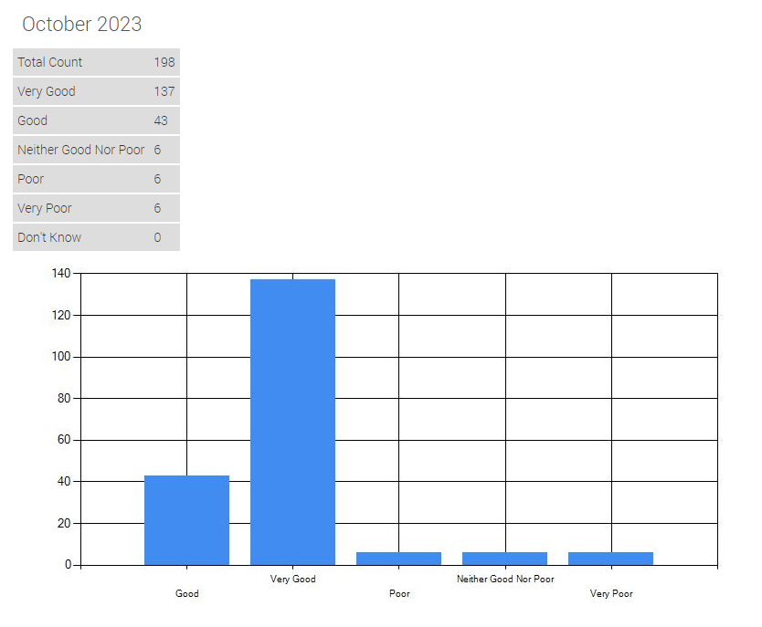
FRIENDS AND FAMILY RESPONSES

