On 29th March 2024, Warley Medical Centre was 20 years old. There are some pictures up in the main reception area showing the building of the centre.

Warley is large training practice, we currently have 5 partners, 2 salaried doctors and 11 registrar doctors.
The registrar doctors are on placement with us for 4 months, 8 months or 12 months depending on where they are in their training.
We have just had 4 doctors finish their placement and 5 new ones start.
Partners
Dr Gahle, Dr Jukes, Dr Desai, Dr Hussain, Dr Wilkinson
Salaried Doctors
Dr Matharu, Dr Edordu
Registrar Doctors
Dr Gangadharan, Dr Eliakim, Dr Sarwar, Dr Adeniyi, Dr Hudyba, Dr Nasir
Dr Martin, Dr Kaur, Dr Chaudary, Dr Welch

You can request an appointment with a particular doctor and we will accommodate this where possible. Sometimes your doctor of choice will not be available for routine appointments and you will be offered a different doctor.
Once all appointments have been booked here at the surgery, patients will be offered an advance booking if available or signposted to other services for help i.e. NHS 111, Walk-in centre, chemist.
Pre-bookable GP, Physicians Associate and Clinical Pharmacist appointments for non-urgent issues are available up to two weeks in advance. Once the pre-bookable appointments have been taken, the remainder of the appointments are then available on the same day for more urgent problems. Same day appointments are primarily face to face consultations.
We offer Face to Face appointments and Telephone First Triage appointments.

Pharmacy First Scheme
Chemists are able to help with a lot of conditions
This new service is expected to free up GP appointments for patients who need them most and will give people quicker and more convenient access to safe and high quality healthcare. It includes the supply of appropriate medicines for 7 common conditions including earache, sore throat, and urinary tract infections, aiming to address health issues before they get worse

Accessing Pharmacy First services
The following table shows the 7 conditions pharmacists can manage across various age ranges.
Clinical pathway Age range
Acute otitis media* 1 to 17 years
Impetigo 1 year and over
Infected insect bites 1 year and over
Shingles 18 years and over
Sinusitis 12 years and over
Sore throat 5 years and over
Uncomplicated urinary tract infections Women 16-64 years

Nursing Team
Nurse Amy, Nurse Monique, Nurse Olivia, HCA Lynn
In January 2022 Nurse Christine retired and we advertised for a replacement nurse to join Nurse Amy and HCA Lynn within the team. In August 2022 we employed 2 new nurses, Nurse Monique and Nurse Olivia.
Nurse appointments are bookable in advance for smears, dressings, injections, med reviews, health checks

On site we also have –
1x physicians associate
2 x mental health practitioners
1 x social prescriber
2 x clinical pharmacists
The upstairs rooms are also used by community services such as foot health, midwives, heart failure team and the anti-coagulant team.
You can self-refer to a few services.
Sandwell Talking Therapies - supports people who are experiencing problems such as stress, anxiety, low mood and depression. You must be aged 16 and over and registered with a GP in Sandwell. Tel : 0121 612 6650
Foot Health - You can self-refer for core services (general podiatry and foot care) if you fall into one of the following categories; Tel: 0121 507 2661
- Aged 65 or over with a foot problem
- Children up to the age of 16 with a foot problem
- Diabetic with a foot problem
- Pregnant women, nursing mothers or mother who have given birth within a year with a foot problem
- Registered disabled with a foot problem
- Individuals with a medical condition that puts their feet at risk without treatment
- Patients requiring nails surgery

Maternity/Midwives - Did you know you can self-refer into the maternity service by clicking the following link: https://www.badgernotes.net/SelfReferral/CareLocation/sandwellwestbirmingham

Health Check Services
We are looking to move all health checks to the patient’s birth month. This helps us manage the demand for appointments and the patients can remember easily when their next check is due.
Long Term Condition (LTC) Checks –
LTC such Diabetes, Asthma, COPD, these checks are done by the nurse. If we need the patient to have bloods done before the health check, they will be asked the month before, giving them 4 weeks to get them done before the appointment.
Well Woman/Man Check –
Warley offers an annual ‘MOT’ with the healthcare assistant for anyone who would like one, we are actively inviting Over 75s and Carers for this check at the moment. It will usually consist of height, weight, BP, smoking status, family history and routine bloods if required.
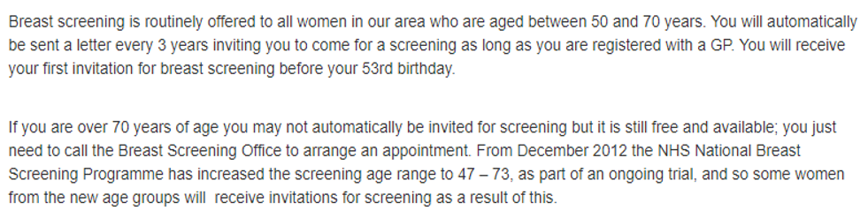
Breast Screening –

Cervical Screening –
Smear tests can be booked in with the practice nurse.
